**Max-min thermometer**

## Step 1: Make it

### What is it?

Track highest and lowest temperatures by leaving this program running on a micro:bit.

## How it works

* Like the Thermometer project, this uses the temperature sensor inside the micro:bit’s CPU (central processing unit) to measure the temperature in °C (Celsius).
* This program keeps track of the lowest and highest temperatures recorded by using 3 **variables**: **currentTemp** is the current temperature reading, **max** is the maximum and **min** is the minimum.
* At the start of the program they are all set to the same value; an infinite (forever) **loop** ensures that every two seconds it takes a reading, and the program compares the current temperature with the **max** and **min** variables.
* If the current temperature is **less than (<)** than the value stored in the **min** variable, it changes the **min** variable to be the same as the current temperature.
* If the current temperature is **greater than (>)** the **max** variable’s value, it changes the **max** variable to be the same as the current temperature.
* The program also flashes a dot on the LED display every time the infinite loop runs so that you know it’s working.
* Press button A to show the minimum and button B to show the maximum temperatures recorded.
* You could leave the micro:bit running for 24 hours, record the maximum and minimum temperatures and plot on a chart at the same time every day and then reset.

### What you need

* micro:bit (or MakeCode simulator)
* MakeCode or Python editor
* battery pack (optional)
* a source of heat or cooling, like a fan, if you want to see the temperature change quickly – or take the micro:bit outside
* graph paper if you want to keep a chart of temperatures over time

## Step 2: Code it

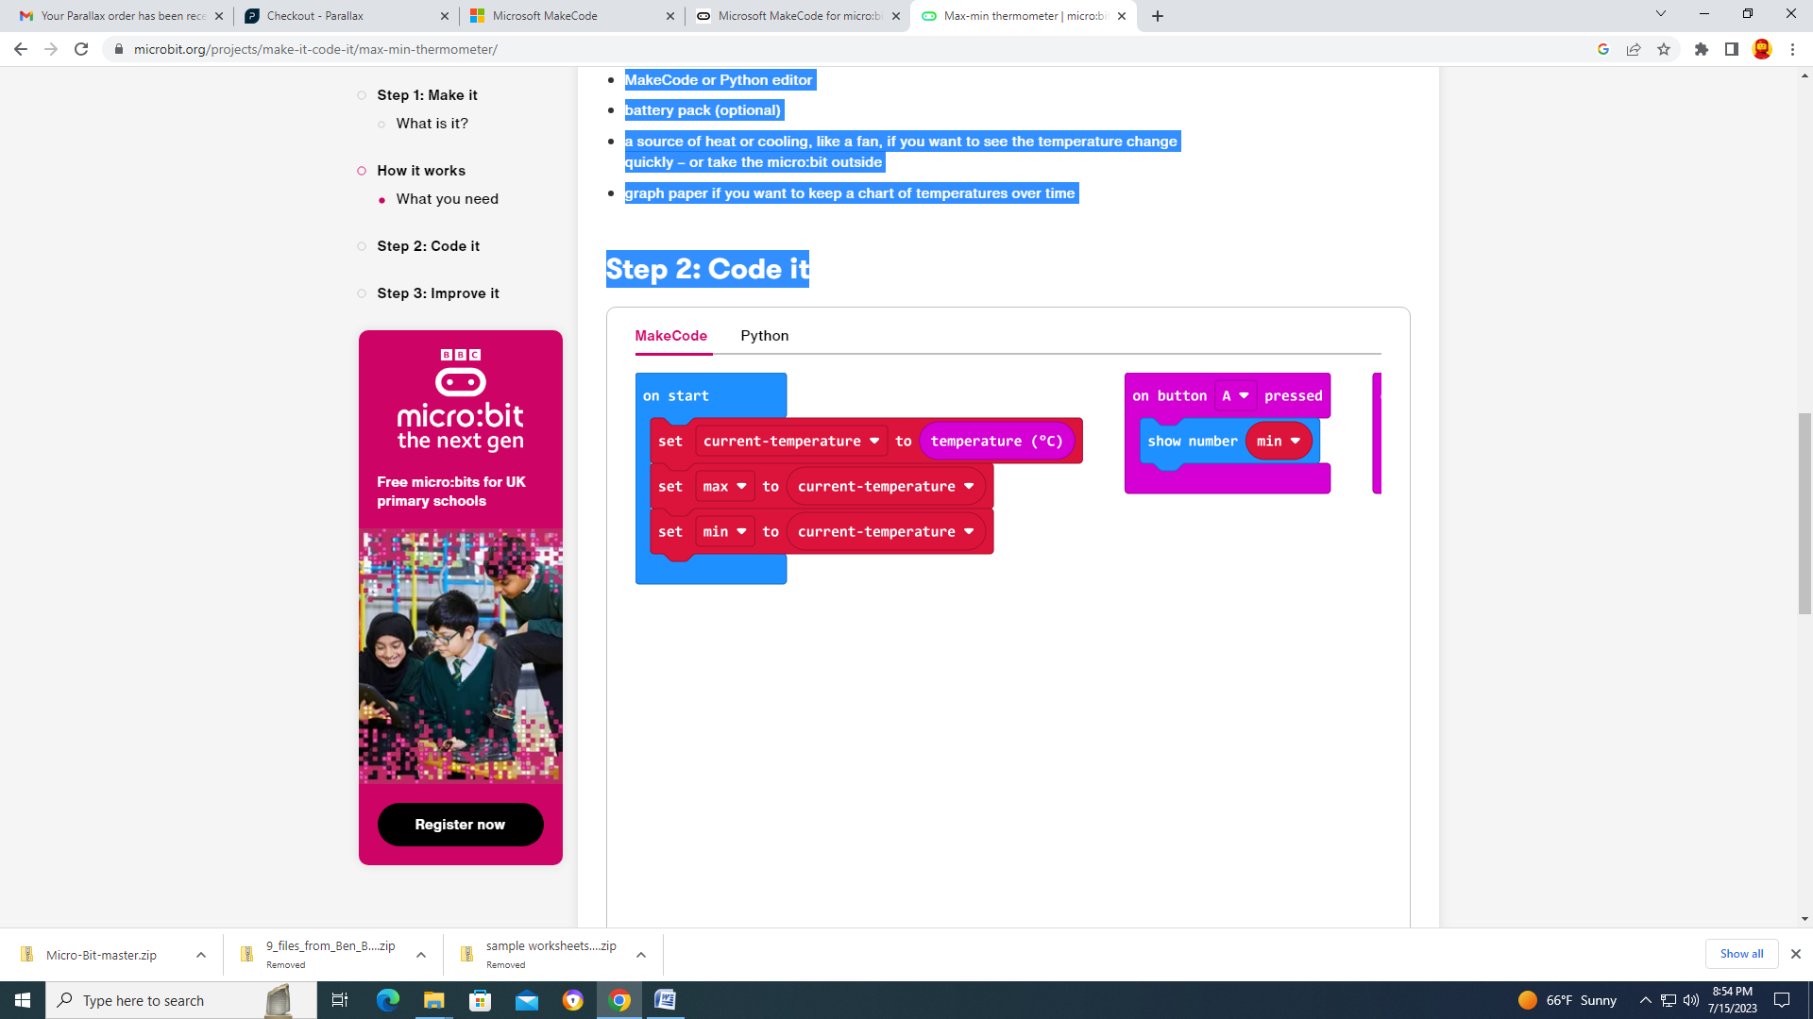

## Step 3: Improve it

* Compare the reading with another thermometer. How accurate is the micro:bit? Do you need to modify the micro:bit reading to get the air temperature? How could you do that?
* Convert the temperature to Fahrenheit.
* Use radio to send temperature readings to another micro:bit.